Lab 07:
Question#01:
CODE:
#include <iostream>
using namespace std;

class Array2D
{
private:
int **data;
int rows, cols;

// allocating memory
void allocate()
{
data = new int *[rows];
for (int i = 0; i < rows; i++)
data[i] = new int[cols]{0}; // initialize to 0
}

// deallocating memory
void deallocate()
{
for (int i = 0; i < rows; i++)
delete[] data[i];
delete[] data;
}

public:
Array2D() : rows(0), cols(0), data(nullptr) {}

Array2D(int r, int c) : rows(r), cols(c)
{
allocate();
}

Array2D(const Array2D &other) : rows(other.rows), cols(other.cols)
{
allocate();
for (int i = 0; i < rows; i++)
for (int j = 0; j < cols; j++)
data[i][j] = other.data[i][j];
}

// Destructor
~Array2D()
{
if (data)
deallocate();
}

Array2D &operator=(const Array2D &other)
{
if (this == &other)
return *this; // self-assignment guard

if (data)
deallocate();

rows = other.rows;
cols = other.cols;
allocate();

for (int i = 0; i < rows; i++)
for (int j = 0; j < cols; j++)
data[i][j] = other.data[i][j];

return *this;
}

Array2D operator+(const Array2D &other) const
{
if (rows != other.rows || cols != other.cols)
{
cout << "Error: Size mismatch for +\n";
return Array2D();
}
Array2D result(rows, cols);
for (int i = 0; i < rows; i++)
for (int j = 0; j < cols; j++)
result.data[i][j] = data[i][j] + other.data[i][j];
return result;
}

Array2D operator-(const Array2D &other) const
{
if (rows != other.rows || cols != other.cols)
{
cout << "Error: Size mismatch for -\n";
return Array2D();
}
Array2D result(rows, cols);
for (int i = 0; i < rows; i++)
for (int j = 0; j < cols; j++)
result.data[i][j] = data[i][j] - other.data[i][j];
return result;
}

Array2D operator*(const Array2D &other) const
{
if (cols != other.rows)
{
cout << "Error: Invalid dimensions for *\n";
return Array2D();
}
Array2D result(rows, other.cols);
for (int i = 0; i < rows; i++)
for (int j = 0; j < other.cols; j++)
for (int k = 0; k < cols; k++)
result.data[i][j] += data[i][k] * other.data[k][j];
return result;
}

int *operator[](int i)
{
return data[i];
}

const int *operator[](int i) const
{
return data[i];
}

void print() const
{
for (int i = 0; i < rows; i++)
{
for (int j = 0; j < cols; j++)
cout << data[i][j] << "\t";
cout << "\n";
}
}

int getRows() const { return rows; }
int getCols() const { return cols; }
};

int main()
{

Array2D A(2, 3), B(2, 3);

int val = 1;
for (int i = 0; i < 2; i++)
for (int j = 0; j < 3; j++)
A[i][j] = val++;

for (int i = 0; i < 2; i++)
for (int j = 0; j < 3; j++)
B[i][j] = val++;

cout << "Matrix A:\n";
A.print();
cout << "\nMatrix B:\n";
B.print();

Array2D C = A + B;
cout << "\nA + B:\n";
C.print();

Array2D D = A - B;
cout << "\nA - B:\n";
D.print();

Array2D X(2, 3), Y(3, 2);
X[0][0] = 1;
X[0][1] = 2;
X[0][2] = 3;
X[1][0] = 4;
X[1][1] = 5;
X[1][2] = 6;

Y[0][0] = 7;
Y[0][1] = 8;
Y[1][0] = 9;
Y[1][1] = 10;
Y[2][0] = 11;
Y[2][1] = 12;

Array2D Z = X * Y;
cout << "\nX (2x3):\n";
X.print();
cout << "\nY (3x2):\n";
Y.print();
cout << "\nX * Y (2x2):\n";
Z.print();

Array2D E = A;
cout << "\nCopy of A:\n";
E.print();

Array2D F;
F = B;
cout << "\nAssigned B to F:\n";
F.print();

return 0;
}

OUTPUT:
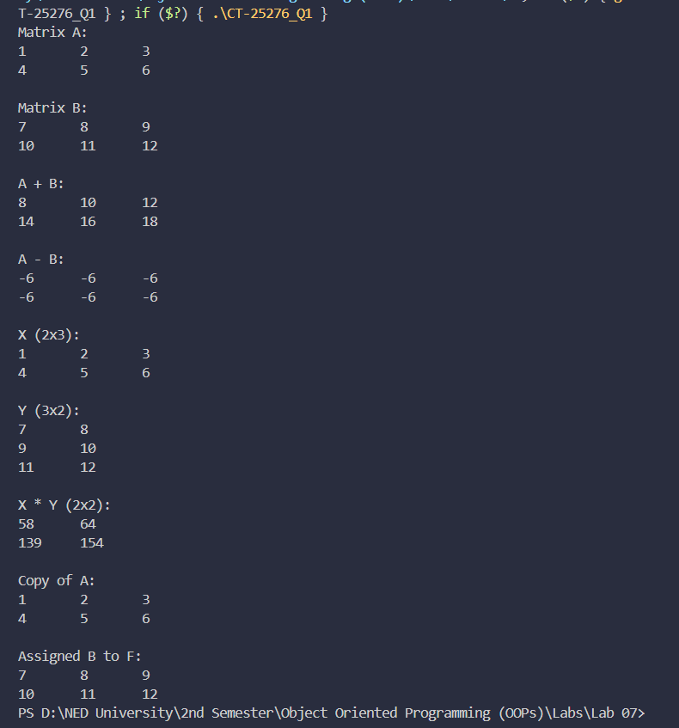

Question#02:
CODE:
#include <iostream>
using namespace std;

class Array2D {
private:
int** data;
int rows, cols;

void allocate() {
data = new int*[rows];
for (int i = 0; i < rows; i++)
data[i] = new int[cols]{0};
}

void deallocate() {
for (int i = 0; i < rows; i++)
delete[] data[i];
delete[] data;
}

public:
Array2D() : rows(0), cols(0), data(nullptr) {}

Array2D(int r, int c) : rows(r), cols(c) { allocate(); }

Array2D(const Array2D& other) : rows(other.rows), cols(other.cols) {
allocate();
for (int i = 0; i < rows; i++)
for (int j = 0; j < cols; j++)
data[i][j] = other.data[i][j];
}

~Array2D() { if (data) deallocate(); }

Array2D& operator=(const Array2D& other) {
if (this == &other) return *this;
if (data) deallocate();
rows = other.rows; cols = other.cols;
allocate();
for (int i = 0; i < rows; i++)
for (int j = 0; j < cols; j++)
data[i][j] = other.data[i][j];
return *this;
}

int* operator[](int i) { return data[i]; }
const int* operator[](int i) const { return data[i]; }

int getRows() const { return rows; }
int getCols() const { return cols; }

void print() const {
for (int i = 0; i < rows; i++) {
for (int j = 0; j < cols; j++)
cout << data[i][j] << "\t";
cout << "\n";
}
}
};

bool searchMatrix(const Array2D& matrix, int target) {
int rows = matrix.getRows();
int cols = matrix.getCols();

if (rows == 0 || cols == 0) return false;

int lo = 0;
int hi = rows * cols - 1; // treat as flat array

while (lo <= hi) {
int mid = lo + (hi - lo) / 2;

// Convert flat index → 2D index
int midVal = matrix[mid / cols][mid % cols];

if (midVal == target)
return true;
else if (midVal < target)
lo = mid + 1;
else
hi = mid - 1;
}

return false;
}

int main() {

// Build the matrix from the examples
Array2D matrix(3, 4);
int vals[3][4] = {
{ 1, 3, 5, 7},
{10, 11, 16, 20},
{23, 30, 34, 60}
};
for (int i = 0; i < 3; i++)
for (int j = 0; j < 4; j++)
matrix[i][j] = vals[i][j];

cout << "Matrix:\n";
matrix.print();
cout << "\n";

// Example 1: target = 3 → true
int t1 = 3;
cout << "Search " << t1 << ": "
<< (searchMatrix(matrix, t1) ? "true" : "false") << "\n";

// Example 2: target = 13 → false
int t2 = 13;
cout << "Search " << t2 << ": "
<< (searchMatrix(matrix, t2) ? "true" : "false") << "\n";

cout << "Search 1: " << (searchMatrix(matrix, 1) ? "true" : "false") << "\n";
cout << "Search 60: " << (searchMatrix(matrix, 60) ? "true" : "false") << "\n";
cout << "Search 25: " << (searchMatrix(matrix, 25) ? "true" : "false") << "\n";

return 0;
}

OUTPUT:
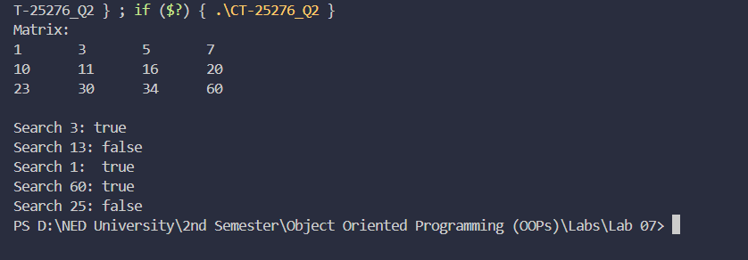

Question#03:
CODE:
#include <iostream>
#include <string>
using namespace std;

class Payroll; // knows Payroll exists.

class Employee
{
private:
string name;
int id;
string designation;
double salary;

public:
Employee(string n, int i, string d, double s)
: name(n), id(i), designation(d), salary(s) {}

void display() const
{
cout << "ID: " << id
<< " | Name: " << name
<< " | Role: " << designation
<< " | Salary: " << salary << "\n";
}

friend class Payroll; // This makes Payroll a friend. Hence, all member functions of Payroll can access Employee's private members.
};

class Payroll
{
public:
void giveRaise(Employee &emp, double amount)
{
emp.salary += amount;
cout << emp.name << "'s salary updated by +" << amount << "\n";
}

void givePercentRaise(Employee &emp, double percent)
{
double increase = emp.salary * (percent / 100.0);
emp.salary += increase;
cout << emp.name << "'s salary updated by " << percent << "%\n";
}

void promote(Employee &emp, string newDesignation, double newSalary)
{
emp.designation = newDesignation;
emp.salary = newSalary;
cout << emp.name << " promoted to " << newDesignation
<< " with salary " << newSalary << "\n";
}
};

int main()
{

// Create employees
Employee e1("Usman Waqas", 101, "Junior Dev", 50000);
Employee e2("Iman Khan", 102, "Designer", 45000);
Employee e3("Faarid Amir", 103, "Manager", 80000);

Payroll payroll;

cout << "===== Before Update =====\n";
e1.display();
e2.display();
e3.display();

payroll.giveRaise(e1, 5000);

payroll.givePercentRaise(e2, 10);

payroll.promote(e3, "Senior Manager", 95000);

cout << "\n===== After Update =====\n";
e1.display();
e2.display();
e3.display();

return 0;
}

OUTPUT:
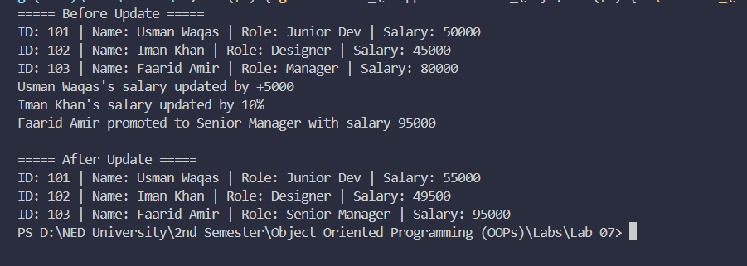

Question#04:
CODE:
#include <iostream>
#include <string>
using namespace std;

class Employee
{
private:
string name;
int id;
string designation;
double salary;

public:
Employee(string n, int i, string d, double s)
: name(n), id(i), designation(d), salary(s) {}

void display() const
{
cout << "ID: " << id
<< " | Name: " << name
<< " | Role: " << designation
<< " | Salary: " << salary << "\n";
}

friend void giveRaise(Employee &emp, double amount);
friend void givePercentRaise(Employee &emp, double percent);
friend void promote(Employee &emp, string newDesignation, double newSalary);
};

void giveRaise(Employee &emp, double amount)
{
emp.salary += amount;
cout << emp.name << "'s salary updated by +" << amount << "\n";
}

void givePercentRaise(Employee &emp, double percent)
{
double increase = emp.salary * (percent / 100.0);
emp.salary += increase;
cout << emp.name << "'s salary updated by " << percent << "%\n";
}

void promote(Employee &emp, string newDesignation, double newSalary)
{
emp.designation = newDesignation;
emp.salary = newSalary;
cout << emp.name << " promoted to " << newDesignation
<< " with salary " << newSalary << "\n";
}

int main()
{

Employee e1("Usman Waqas", 101, "Junior Dev", 50000);
Employee e2("Iman Khan", 102, "Designer", 45000);
Employee e3("Faarid Amir", 103, "Manager", 80000);

cout << "===== Before Update =====\n";
e1.display();
e2.display();
e3.display();

giveRaise(e1, 5000);
givePercentRaise(e2, 10);
promote(e3, "Senior Manager", 95000);

cout << "\n===== After Update =====\n";
e1.display();
e2.display();
e3.display();

return 0;
}

OUTPUT:
